APPENDIX 1: Barclay’s Bank’s policy on investing in Burma:

* Barclays does not have offices or representation in Burma/Myanmar.
* We do not lend to the Military Regime, or any government body in Burma.
* Barclays does not have any lending to Burmese companies or individuals.

Source:

Philippa Birtwell
Head of Public Issues
Public Policy
Direct Tel: 020 7699 2644
Fax: 020 7699 2683
Email: philippa.birtwell@barclays.co.uk

APPENDIX 2: Examples of socially responsible investment products:

Standard Life UK ethical

Source http://uk.standardlifeinvestments.com/content/products/institutional/OI/prices.html

The Standard Life UK institutional OEIC includes an ethical subfund: the UK Ethical Fund. If St Hugh’s were to invest in the Standard Life OEIC, it could perhaps make a commitment to invest an agreed percentage of the endowment in the Ethical sub fund

Information on this sub fund, and graph showing performance

Share types available | Accumulation
Initial charge | 0%
Annual management charge | 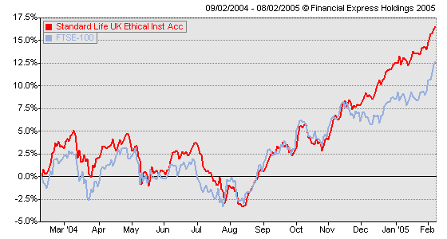  0.5% deducted from income
Other fund expenses | 0.10% per annum
Min initial lump sum investment | £250,000
Min additional lump sum | £50,000
Min withdrawal | £5,000
Min holding | £50,000
End of accounting period | 28 Feb
Distribution dates | 30 Apr
Launch date  Fund size (Jan 2005)  Nº holdings | 16 February 1998  £61.71m  82

According to www.ethicalinvestors.co.uk (last updated September 01), the exclusion criteria used by the Standard Life UK ethical fund are as follows:

The Fund will not invest in:

- Companies which have repeatedly discharged effluent into rivers, estuaries or underground or coastal waters in the last year.
- Companies which supply ozone depleting chemicals.
- Companies which manufacture pesticide products.
- Companies which have been convicted following a prosecution by the Environment Agency or the Scottish Environment Agency.
- Companies which products or ingredients have been tested, by themselves or their suppliers, on animals.
- Companies that operate in regimes which are rated poorly by Freedom House will be avoided.
- Companies that publish or print material or wholesale magazines which portray men, women or children in a sexually explicit and degrading manner, including sexual violence will be avoided. Our policy also excludes companies that distribute pornographic films or videos.
- Companies who sell or produce weapons, including nuclear weapons, will be avoided.
- Companies that own or operate nuclear power stations will be avoided.
- Companies which produce alcohol.
- Companies which manufacture tobacco products.
- Companies who derive any turnover from gambling will not be included in the Fund.

Henderson Global Investors

Source http://www.henderson.com/home/sri/henderson_sri_funds/default.asp

Henderson Global Investors offers 3 OEICs, with more stringent ethical criteria than those of other most other ready made ethical funds available:

1) Henderson Global Care Growth

Initial charge | nil
Annual management charge | 0.5 %

Nº holdings | 91
Size of fund | £204.6 m
Yield (for class I), month ended 30 Jun 04 | 0.84%

The exclusion criteria of this fund are very stringent, for example:
  - Any companies which produce or process meat or dairy products are excluded, as are those which profit largely from the sale of meat and dairy products
  - Companies directly involving mining or quarrying are excluded

2) Henderson Global Care Income

Initial charge | nil
Annual management charge (charged to capital rather than income) | 0.5 %

Nº holdings | 76
Size of fund | £104.3 m
Yield (for class I), month ended 30 Jun 04 | 2.80 %

The ethical policy of this fund is less stringent than that of the Global Care Growth fund, in that
  - There is no exclusion of meat and dairy producing/processing/selling companies.
  - Mining companies, oil companies, car manufacturing companies and pharmaceutical companies which test on animals may be included if they demonstrate ‘an outstandingly positive response towards environmental and social concerns.’

Henderson Global Care Managed

Initial charge | nil
Annual management charge | 0.5 %

Nº holdings | 120
Size of fund | £443.9 m
Yield (for class I), month ended 30 Jun 04 | 2.42%

The ethical policy of this fund is similar to that of the Global Care Income fund.

Morley fund management

Morley fund management offers a wide range of socially responsible investment products, which can be found on their website:

http://www.morleyfm.com/institutional/sri/index.htm

